**Assumption:**

Status ‘Finished’ in column rewardsReceiptStatus of receipts data table is same as ‘Accepted’.

**ER DIAGRAM:**

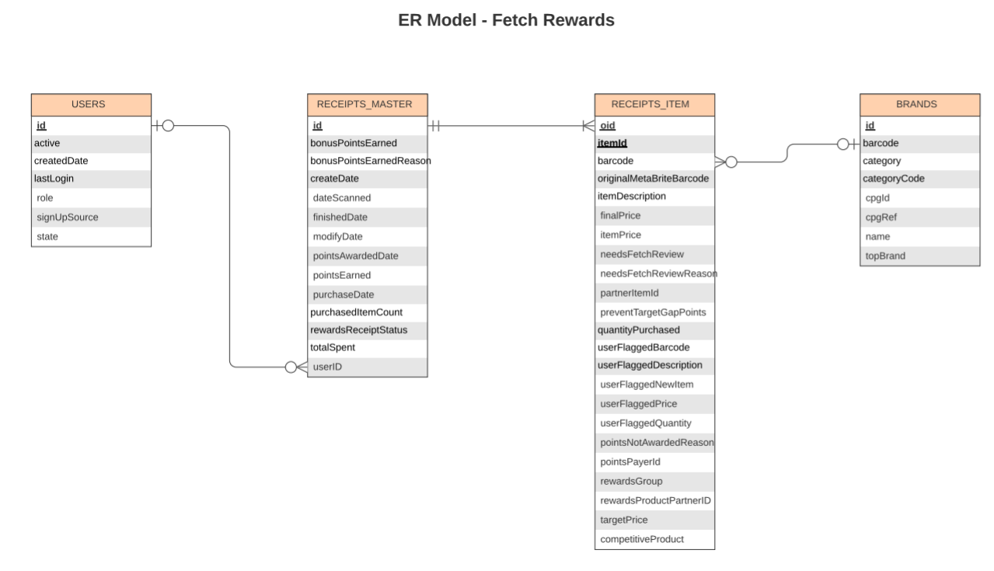**Relational Schema: Primary and Foreign Keys in Tables**

**Legend**:

1. Bold and underlined columns are the primary key in that table. If a table has more than such columns, then they are both the composite primary key for the table.2.
2. Bold, underlined and italicized columns are the foreign keys in a table with a link to another table.

USERS(**id**, active, createdDate,lastLogin,role,signUpSource,state)

RECEIPTS_MASTER(**id**,***userID,***bonusPointsEarned,bonusPointsEarnedReason,createDate,dateScanned,finishedDate,modifyDate,pointsAwardedDate,pointsEarned,purchaseDate,purchaseItemCount,rewardsReceiptStatus,totalSpent)

RECEIPTS_ITEM(**oid**,**itemID**,***barcode***,originalMetaBriteBarcode,itemDescription,finalPrice,itemPrice,needsFetchReview,needsFetchReviewReason,partnerItemId,preventTargetGroupPoints,quantityPurchased,userFlaggedBarcode,userFlaggedDescription,userFlaggedNewItem,userFlaggedPrice,userFaggedQuantity,pointsNotAwardedReason,pointsPayerId,rewardsGroup,rewardsProductPartnerId,targetPrice,competitiveProduct )

BRANDS(**id,**barcode,category,categoryCode,cpgId,cpgRef,name,topBrand)